**Modern College of Arts, Science and Commerce, Pune-05**

**Department of Statistics**

**Practical no :**

**Practical title: Realization Of Markov Chain .**

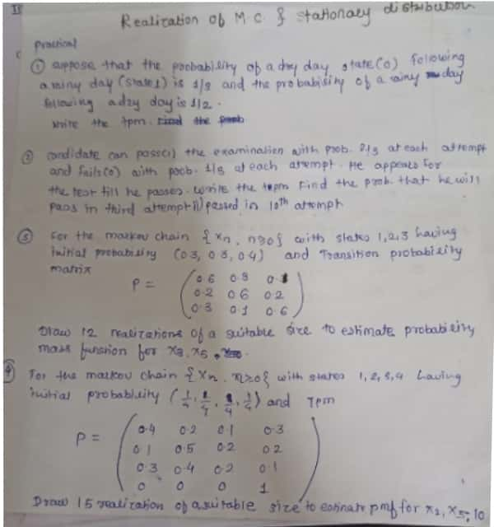

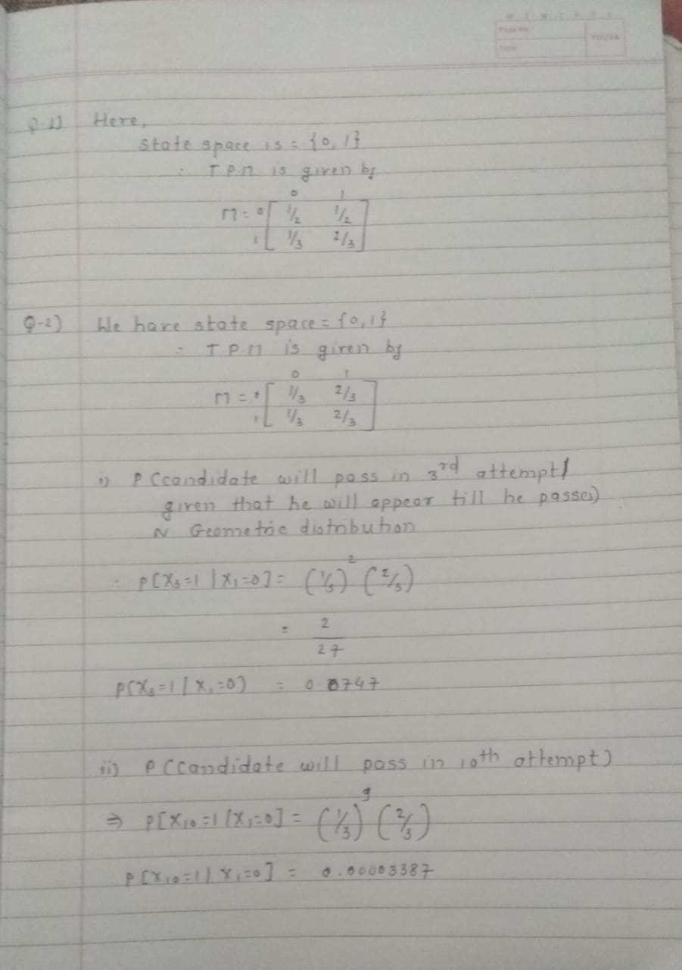

> #Q3)

> n=6

> N=12

> sp=3 # No. of states

> d=c(0.6,0.3,0.1,0.2,0.6,0.2,0.3,0.1,0.6)

> p=matrix(d,nrow=3,ncol=3,byrow=T)

> p # t.p.m

[,1] [,2] [,3]

[1,] 0.6 0.3 0.1

[2,] 0.2 0.6 0.2

[3,] 0.3 0.1 0.6

> r=matrix(rep(0,n*N),nrow=n,ncol=N)

> s=matrix(rep(0,n*N),nrow=n,ncol=N)

> for(i in 1:n)

+ {

+ for(j in 1:N)

+ {

+ r[i,j]<-runif(1,0,1)

+ if(i==1)

+ {

+ if(0<r[i,j]&& r[i,j]<=0.3) {s[i,j]=1};

+ if(0.3<r[i,j]&& r[i,j]<=0.6) {s[i,j]=2};

+ if(0.6<r[i,j]&& r[i,j]<=1) {s[i,j]=3}

+ }

+ else

+ {

+ if(s[i-1,j]==1)

+ {

+ if(0<r[i,j]&& r[i,j]<=0.6) {s[i,j]=1};

+ if(0.6<r[i,j]&& r[i,j]<=0.9) {s[i,j]=2};

+ if(0.9<r[i,j]&& r[i,j]<=1) {s[i,j]=3}

+ }

+ if(s[i-1,j]==2)

+ {

+ if(0<r[i,j]&& r[i,j]<=0.2) {s[i,j]=1};

+ if(0.2<r[i,j]&& r[i,j]<=0.8) {s[i,j]=2};

+ if(0.8<r[i,j]&& r[i,j]<=1) {s[i,j]=3}

+ }

+ if(s[i-1,j]==3)

+ {

+ if(0<r[i,j]&& r[i,j]<=0.3) {s[i,j]=1};

+ if(0.3<r[i,j]&& r[i,j]<=0.4) {s[i,j]=2};

+ if(0.4<r[i,j]&& r[i,j]<=1) {s[i,j]=3}

+ }

+ }

+ }

+ }

> r # Random number matrix

[,1] [,2] [,3] [,4] [,5] [,6] [,7] [,8] [,9] [,10] [,11]

[1,] 0.01252684 0.8441174 0.5627543 0.423723801 0.0614072 0.01090788 0.7140858 0.8937710 0.5061580 0.07333139 0.05525655

[2,] 0.37964617 0.7832153 0.7768643 0.138795816 0.1426588 0.69728848 0.4156381 0.7926716 0.3481220 0.99655936 0.13763568

[3,] 0.03265972 0.3946279 0.2584937 0.123532978 0.2752563 0.87681541 0.1000177 0.5332418 0.6968378 0.27702423 0.83960737

[4,] 0.38154198 0.5726106 0.8633293 0.313376580 0.2147257 0.01164878 0.9530896 0.9305682 0.9497029 0.21182563 0.83762713

[5,] 0.34142092 0.6421002 0.8399170 0.273239450 0.8816974 0.79786673 0.8547393 0.4927929 0.5607058 0.82337755 0.97256400

[6,] 0.44615879 0.6075319 0.5243965 0.001283959 0.6727352 0.01370063 0.4844379 0.4037529 0.4926304 0.90756780 0.65120197

[,12]

[1,] 0.7369716

[2,] 0.2987434

[3,] 0.1473025

[4,] 0.9593293

[5,] 0.4965737

[6,] 0.4290972

> s # state space matrix

[,1] [,2] [,3] [,4] [,5] [,6] [,7] [,8] [,9] [,10] [,11] [,12]

[1,] 1 3 2 2 1 1 3 3 2 1 1 3

[2,] 1 3 2 1 1 2 3 3 2 3 1 1

[3,] 1 2 2 1 1 3 1 3 2 1 2 1

[4,] 1 2 3 1 1 1 3 3 3 1 3 3

[5,] 1 2 3 1 2 2 3 3 3 2 3 3

[6,] 1 2 3 1 2 1 3 3 3 3 3 3

> # Function for estimating p.m.f. of x

> f=function(i,sp,s)

+ {

+ alpha=c();

+ for(j in 1:sp) {alpha[j]<-length(which(s[i+1,]==j))/N}

+ cat("Estimated p.m.f. of X",i,"is\n",alpha)

+ }

> # where i: Variable no. for which we have to find the estimate of the p.m.f.

> # sp: Total no. of states space

> # s: Matrix of state space

> f(3,3,s) # Estimated pmf of X3

Estimated p.m.f. of X 3 is

0.4166667 0.08333333 0.5

> f(5,3,s) # Estimated pmf of X5

Estimated p.m.f. of X 5 is

0.25 0.1666667 0.5833333

>#Q4)

> n=11; N=15; sp=4; # sp=No. of states

> P=matrix(c(0.4,0.2,0.1,0.3,0.1,0.5,0.2,0.2,0.3,0.4,0.2,0.1,0,0,0,1),nrow=sp,ncol=sp,byrow = TRUE)

> P # t.p.m.

[,1] [,2] [,3] [,4]

[1,] 0.4 0.2 0.1 0.3

[2,] 0.1 0.5 0.2 0.2

[3,] 0.3 0.4 0.2 0.1

[4,] 0.0 0.0 0.0 1.0

> r=matrix(rep(0,n*N),nrow=n,ncol=N)

> s=matrix(rep(0,n*N),nrow=n,ncol=N)

> for(j in 1:N) {

+ for(i in 1:n) {

+ r[i,j]<-runif(1,0,1)

+ if(i==1) {

+ if(r[i,j]>0&&r[i,j]<=1/4) {s[i,j]=1}

+ else if(r[i,j]>1/4&&r[i,j]<=2/4) {s[i,j]=2}

+ else if(r[i,j]>2/4&&r[i,j]<=3/4) {s[i,j]=3}

+ else {s[i,j]=4}

+ }

+ else {

+ if(s[i-1,j]==1) {

+ if(r[i,j]>0&&r[i,j]<=0.4) {s[i,j]=1}

+ else if(r[i,j]>0.4&&r[i,j]<=0.6) {s[i,j]=2}

+ else if(r[i,j]>0.6&&r[i,j]<=0.7) {s[i,j]=3}

+ else {s[i,j]=4}

+ }

+ else if(s[i-1,j]==2) {

+ if(r[i,j]>0&&r[i,j]<=0.1) {s[i,j]=1}

+ else if(r[i,j]>0.1&&r[i,j]<=0.6) {s[i,j]=2}

+ else if(r[i,j]>0.6&&r[i,j]<=0.8) {s[i,j]=3}

+ else {s[i,j]=4}

+ }

+ else if(s[i-1,j]==3) {

+ if(r[i,j]>0&&r[i,j]<=0.3) {s[i,j]=1}

+ else if(r[i,j]>0.3&&r[i,j]<=0.7) {s[i,j]=2}

+ else if(r[i,j]>0.7&&r[i,j]<=0.9) {s[i,j]=3}

+ else {s[i,j]=4}

+ }

+ else {s[i,j]=4}

+ }

+ }

+ }

> r # random number matrix

[,1] [,2] [,3] [,4] [,5] [,6] [,7] [,8] [,9] [,10]

[1,] 0.79201810 0.8065535 0.9342617 0.67771272 0.47638092 0.18809959 0.45941680 0.02919110 0.22671757 0.4121299

[2,] 0.79791910 0.9444168 0.2734105 0.13305703 0.78832636 0.43144889 0.16333280 0.24263925 0.35807909 0.6701468

[3,] 0.77366455 0.9220843 0.1141080 0.37278798 0.12885540 0.17650906 0.24870271 0.37133097 0.92404822 0.4084372

[4,] 0.40700957 0.8458686 0.9034581 0.54615418 0.39037952 0.29517133 0.74298082 0.79629644 0.21721537 0.8037300

[5,] 0.81309292 0.6083939 0.9332875 0.69027889 0.96940820 0.34898990 0.49523541 0.88643019 0.94704340 0.4651015

[6,] 0.07783612 0.4516491 0.9994554 0.06994143 0.74666687 0.96397876 0.41079700 0.19131275 0.79139241 0.3175549

[7,] 0.72029130 0.6897637 0.7375259 0.01067580 0.34254936 0.98194604 0.08071694 0.88685333 0.50147411 0.8654403

[8,] 0.30165008 0.7474215 0.9948037 0.72359203 0.55334650 0.85912422 0.70587454 0.35891039 0.44260485 0.1467600

[9,] 0.63905017 0.9548280 0.0543399 0.73881301 0.40356114 0.22180420 0.65416750 0.04564017 0.42072425 0.8697188

[10,] 0.06676628 0.4518567 0.5084862 0.10179048 0.09448237 0.10366594 0.67176820 0.90418043 0.17989853 0.8837198

[11,] 0.78294073 0.3139885 0.6241179 0.12376944 0.17011282 0.04815401 0.44203310 0.18774328 0.06309493 0.8539248

[,11] [,12] [,13] [,14] [,15]

[1,] 0.24348929 0.04896965 0.15401698 0.15907896 0.7674593

[2,] 0.40270232 0.34151467 0.98927365 0.23487266 0.7229886

[3,] 0.35869793 0.47996420 0.09696734 0.53939849 0.2026277

[4,] 0.21321622 0.41099764 0.94742197 0.45994560 0.6149412

[5,] 0.50264656 0.25883423 0.14676784 0.07559367 0.4442607

[6,] 0.46164166 0.90587973 0.19826795 0.12298724 0.5831456

[7,] 0.43702006 0.76863026 0.59666148 0.99390483 0.4300036

[8,] 0.31115062 0.58392437 0.23549721 0.43607011 0.3427870

[9,] 0.31384403 0.82114174 0.59587572 0.11648054 0.2323927

[10,] 0.48543965 0.58107407 0.21472494 0.18906368 0.2022752

[11,] 0.03870431 0.03884976 0.56843785 0.88324839 0.4116153

>

>

>

> s #state space matrix

[,1] [,2] [,3] [,4] [,5] [,6] [,7] [,8] [,9] [,10] [,11] [,12] [,13] [,14] [,15]

[1,] 4 4 4 3 2 1 2 1 1 2 1 1 1 1 4

[2,] 4 4 4 1 3 2 2 1 1 3 2 1 4 1 4

[3,] 4 4 4 1 1 2 2 1 4 2 2 2 4 2 4

[4,] 4 4 4 2 1 2 3 4 4 4 2 2 4 2 4

[5,] 4 4 4 3 4 2 2 4 4 4 2 2 4 1 4

[6,] 4 4 4 1 4 4 2 4 4 4 2 4 4 1 4

[7,] 4 4 4 1 4 4 1 4 4 4 2 4 4 4 4

[8,] 4 4 4 4 4 4 4 4 4 4 2 4 4 4 4

[9,] 4 4 4 4 4 4 4 4 4 4 2 4 4 4 4

[10,] 4 4 4 4 4 4 4 4 4 4 2 4 4 4 4

[11,] 4 4 4 4 4 4 4 4 4 4 1 4 4 4 4

>

>

> # Function for estimating p.m.f. of x

>

> f=function(i,sp,s)

+ {

+ alpha=c();

+ for(j in 1:sp) {alpha[j]<-length(which(s[i+1,]==j))/N}

+ cat("Estimated p.m.f. of X",i,"is\n",alpha)

+ }

> # where i: Variable no. for which we have to find the estimate of the p.m.f.

> # sp: Total no. of states space

> # s: Matrix of state space

>

> f(2,4,s) # Estimated pmf of X2

Estimated p.m.f. of X 2 is

0.2 0.4 0 0.4>

>

> f(5,4,s) # Estimated pmf of X5

Estimated p.m.f. of X 5 is

0.1333333 0.1333333 0 0.7333333>

>

> f(10,4,s) # Estimated pmf of X10

Estimated p.m.f. of X 10 is

0.06666667 0 0 0.9333333

>